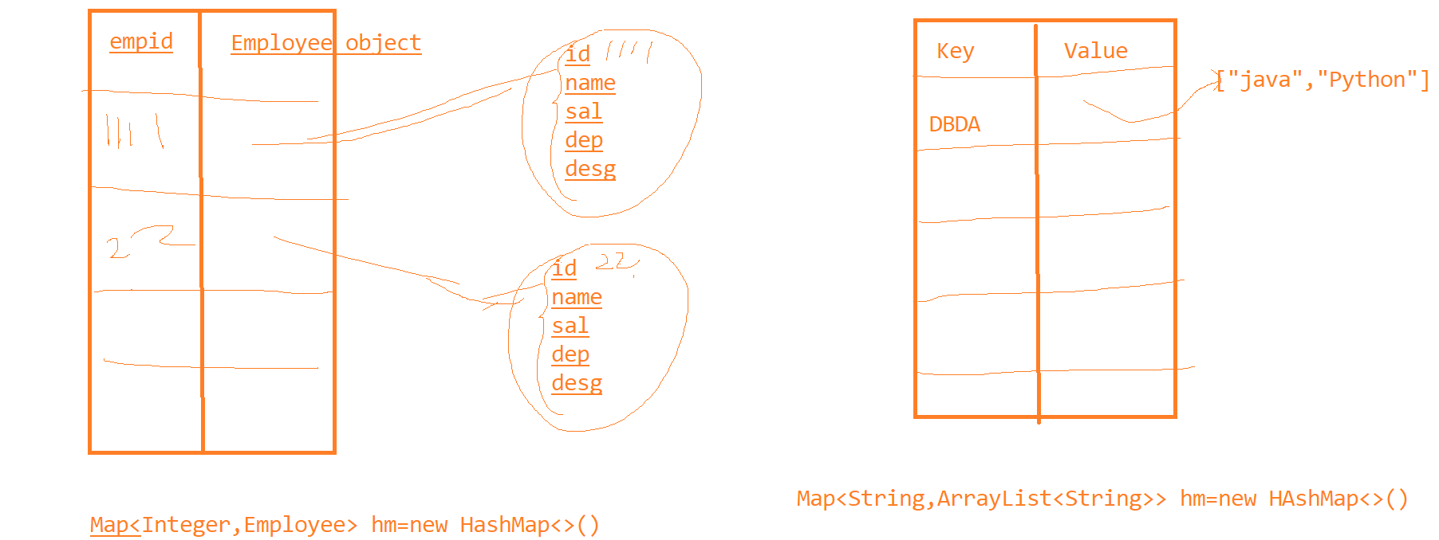

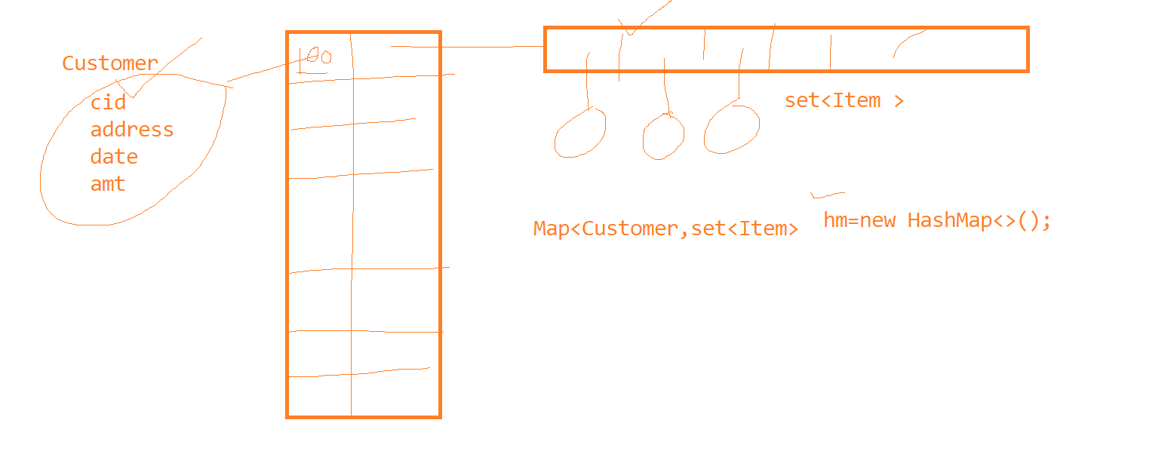

|  |  |
| --- | --- |
| Class |  |
| HashTable | All methods are Synchronized, null key is not allowed |
| HashMap | Methods are not synchronized, one null key is allowed |
| LinkedHashMap | This is ordered collection and also faster in searching because of hashing |
| TreeMap | Data is always sorted on keys |
|  |  |
|  |  |